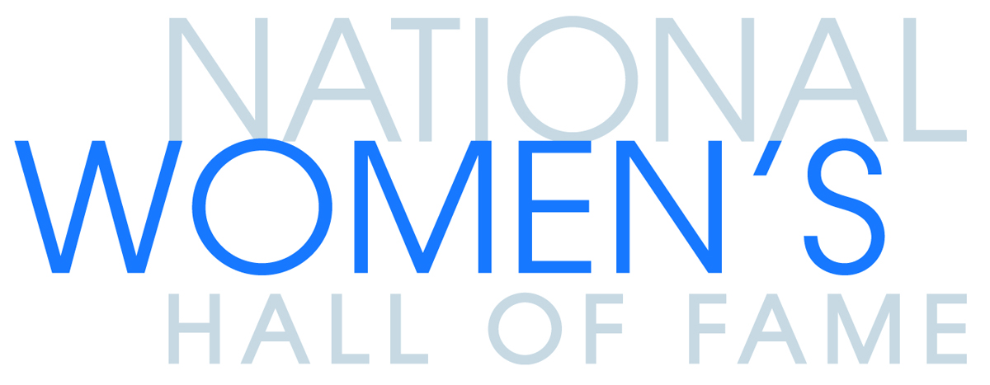
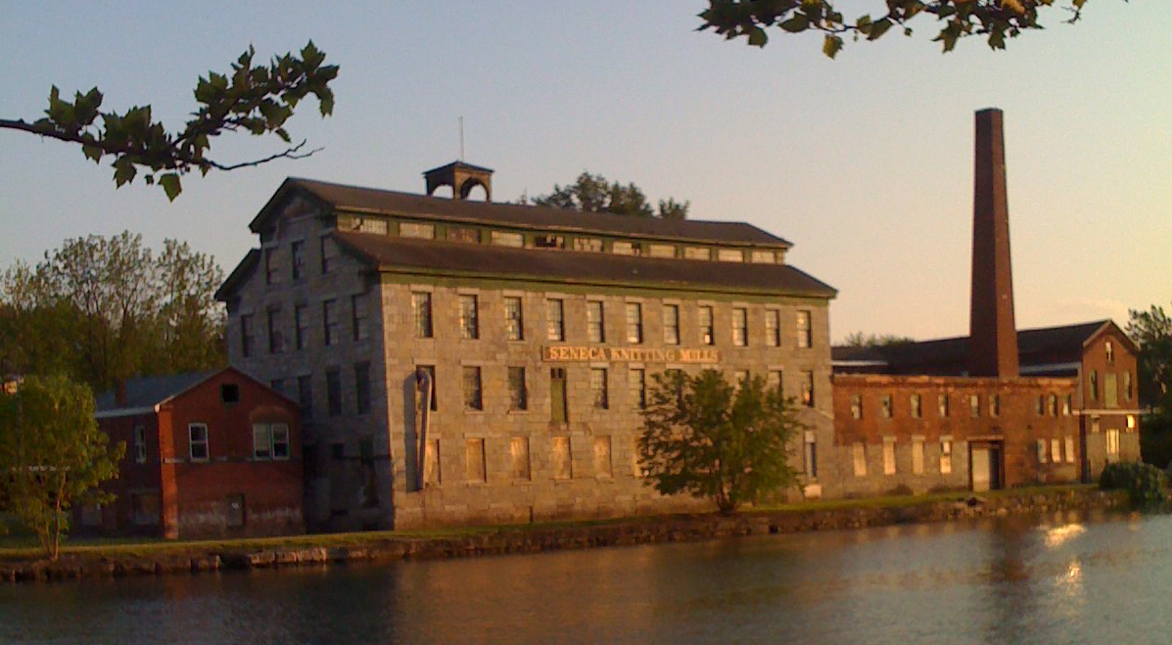
Creation of the Center for Great Women
in the Historic Seneca Knitting Mill

The National Women’s Hall of Fame seeks to enhance the public’s understanding of American history and culture by showcasing and preserving the stories of pioneering American woman whose achievements have enduring value, are of national importance, and have significance both in our country and the world. The Hall is adaptively rehabilitating the Seneca Knitting Mill into the Center for Great Women in Seneca Falls, New York, the birthplace of women’s rights. This state-of-the-art educational venue will serve as an interdisciplinary thought center, preserving the past and present stories of great American women while inspiring and supporting future generations of women leaders. The Center for Great Women will preserve an historic structure, located on a branch of the Erie Canal system, and honor the laborers, primarily women, who worked there from 1844 until its closure in 1999.

NAMING OPPORTUNITIES*
(DRAFT as of December 17, 2014)

$10,000,000
Building

$3,000,000
Atrium Lobby
Roof Top Garden

$1,500,000
Exhibit Hall
Smoke Stack
Bell Tower

$750,000
Hall Gallery

$500,000
2015 Inductees Exhibit
2013 Inductees Exhibit
Cafe

$300,000
Learning and Media Center
Lives and Legacies Exhibit
Archival and Research Center

$250,000
Mill History Exhibit
Traveling Exhibit Gallery
Outdoor Learning Circle

$150,000 - $300,000 (Individual Galleries)
Hall of Arts
Hall of Athletics
Hall of Business
Hall of Education
Hall of Government
Hall of Humanities
Hall of Philanthropy
Hall of Sciences

$50,000 - $100,000
Rose Garden
Reception Desk
Administration Area
Director’s Office
Landscaping Features

*Naming opportunities can be discussed and will be finalized upon completion of construction documents.

